32 Day notice – Workaround

Scenario:

1. Notice loaded expires on 2016/12/26:

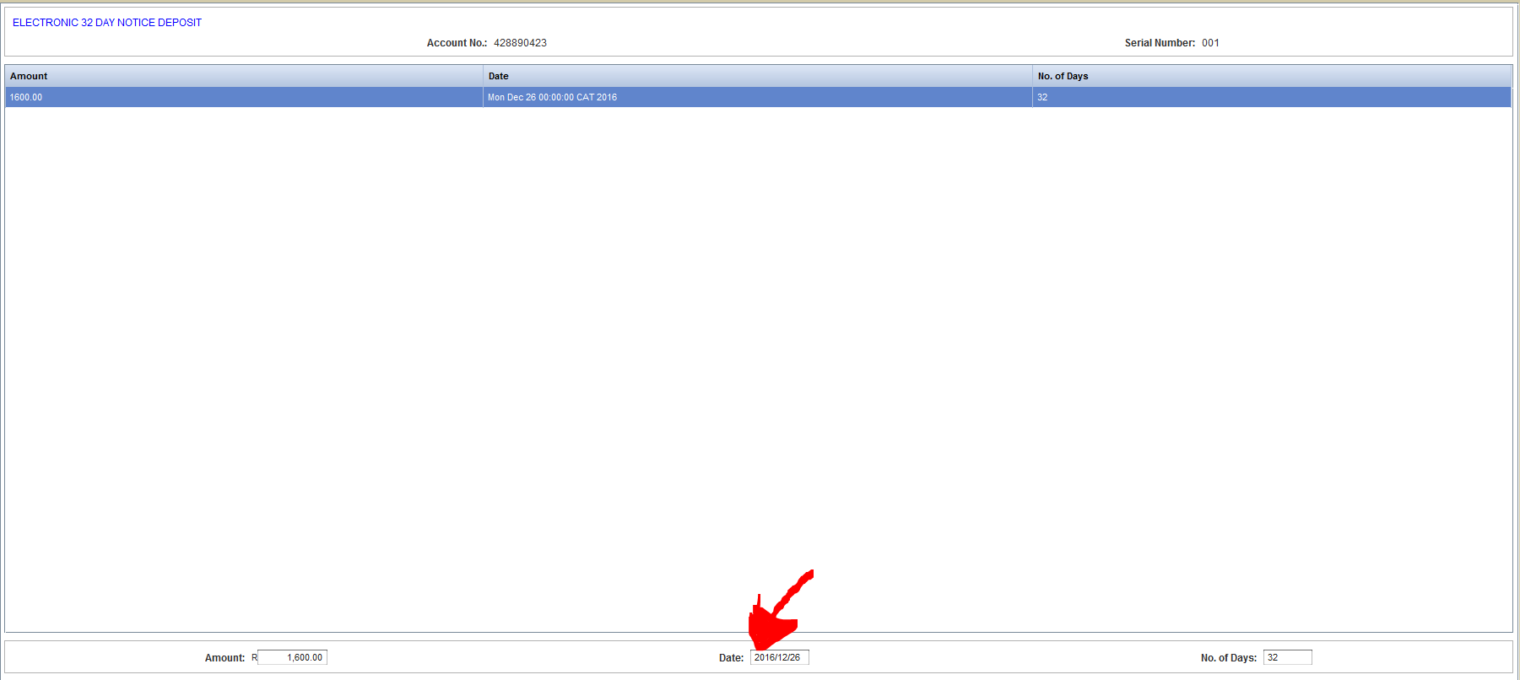

2. On the next screen add 1 more day to the maturity date (2016/12/27) and amend the period to 33 days, and confirm.

